The week in 7 charts
2nd of November 2026

Chart #1: Crypto giant Binance hit by $6.3bn hack suspected to be largest in history

Binance has suffered a hack with estimated losses of up to $6.3 billion, which would make it the largest crypto theft on record. Context, however, matters.

The breach at Binance is estimated at $6.3 billion, of which about $3 billion has been frozen so far, and the exchange has pledged to cover all losses. This is a serious incident, and its final financial cost is still being assessed.

The headline figure, however, tells only part of the story. Based on the estimates in the chart below, the stolen amount equals roughly 0.23% of total crypto market capitalisation. By comparison:
• Mt. Gox, 2014: 5.84%
• Bitfinex, 2016: 0.65%
• The DAO, 2016: 0.43%

Because the crypto market is far larger today, this incident ranks below several earlier breaches in relative terms.

None of this excuses the security failure, and market capitalisation is no measure of an exchange’s capacity to absorb losses. It does, however, help separate a major operational incident from claims that the whole industry is collapsing. The security concerns stand, but they should be weighed against the size of the market.

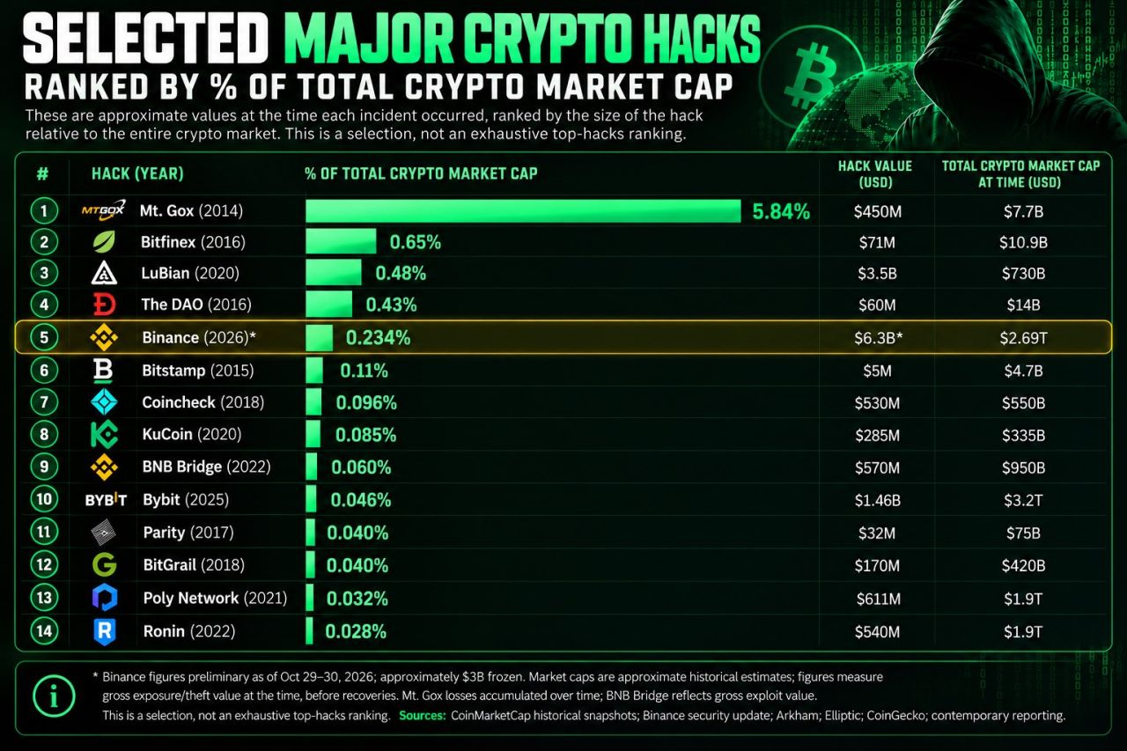

Source : bitcorn

Chart #2: The Big 4 have now revealed their quarterly CapEx spending with a combined total surpassing $200 billion

• Amazon: about $77 billion
• Alphabet: about $51 billion
• Microsoft: about $39 billion
• Meta: about $34 billion

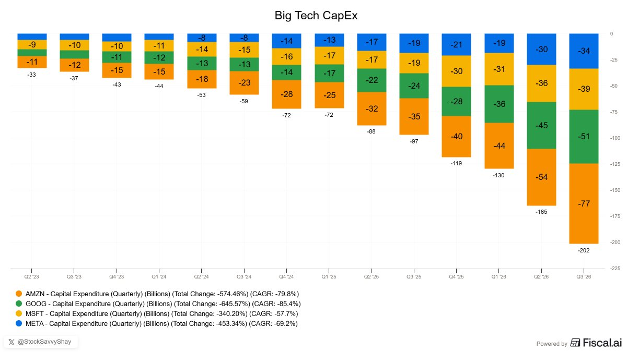

Source: Fiscal.ai

Chart #3: Where are asset managers most bearish in Q4 2026 investment outlooks?

ProAllocate reviewed more than 120 outlooks and asset allocation papers from 76 firms, covering views on over 450 sub-asset classes, factors, themes and markets.

The most widely shared underweight was...

French government bonds (OATs)
↳ Managers cited France’s public finances and political situation, which have pushed the spread between French and German 10-year yields to its widest level since the euro debt crisis.

🌍 Within equities, managers are cautious on Consumer Staples, European Listed Real Estate and Australian Equities.

📄 Fixed income as a whole is out of favour, with Long Duration, Low Quality Issuers and Global Investment Grade Credit all receiving low scores.

🛣️ In Alternatives, oil is unsurprisingly unpopular after this year’s sharp price swings.

💵 Cash is also an underweight, although sentiment towards it has improved since last quarter.

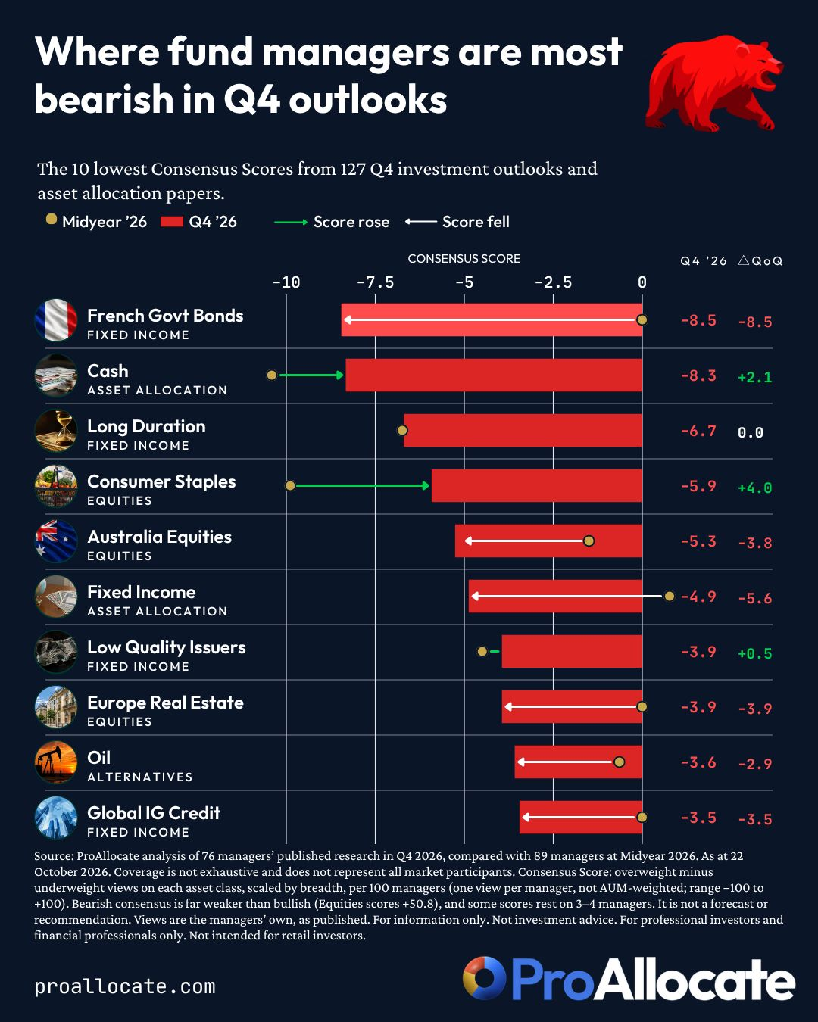

Source. Stephen White

Chart #4: Where are asset managers most bullish in Q4 2026 investment outlooks?

ProAllocate reviewed more than 120 outlooks and asset allocation papers from 76 firms, spanning views on over 450 sub-asset classes, factors, themes and markets.

The clearest consensus call was...

Equities 📈: 52 of the 66 firms expressing a view were overweight, 11 were neutral and just 3 were underweight. Most cite double-digit earnings growth, resilient nominal growth and AI investment broadening beyond big tech. The more cautious minority highlights rate hikes, higher real yields and oil prices.

Which other positions do asset managers favour over a tactical asset allocation horizon (6-12 months)?

🌍 Within equities, managers favour the US, emerging markets, Japan and AI-related stocks, albeit selectively.
📄 In fixed income, only local-currency EM debt makes the top 10.
🛣️ In Alternatives, firms remain positive on gold, real assets, private infrastructure and commodities more broadly.

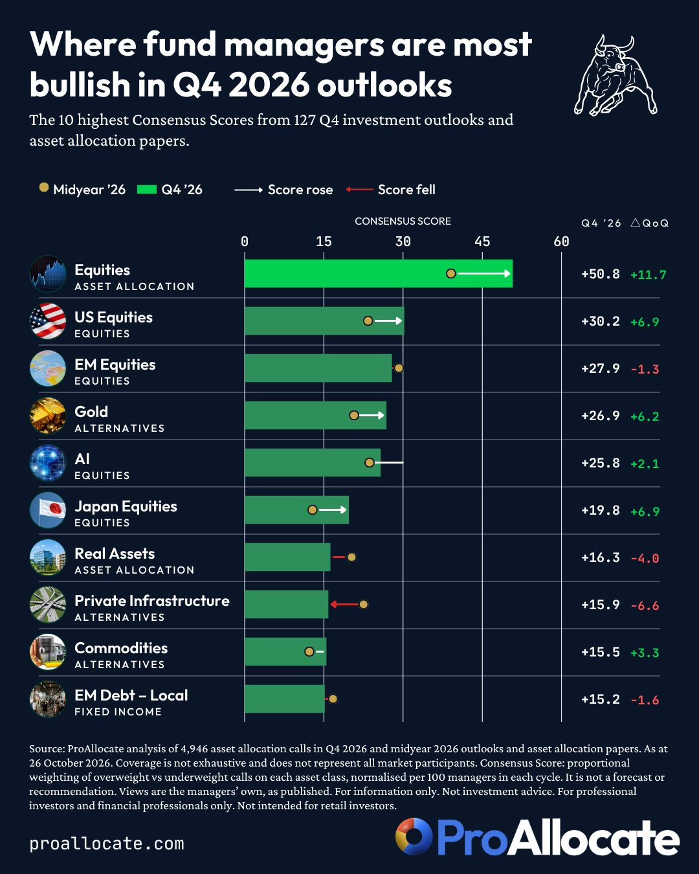

Source: Stephen White

Chart #5: Anthropic is generating an extraordinary $6.6 million in revenue per employee

This places the AI company ahead of Nvidia, Meta, Apple and Google, and behind only OnlyFans among the companies listed:

▫️ OnlyFans: $33.0 million
▫️ Anthropic: $6.6 million
▫️ AppLovin: $6.1 million
▫️ Nvidia: $5.1 million
▫️ Netflix: $2.8 million
▫️ Grindr: $2.7 million
▫️ Meta: $2.5 million
▫️ Apple: $2.5 million
▫️ Google: $2.1 million

An important caveat: revenue per employee measures how much revenue a company generates relative to its workforce, but reveals little about its profitability or infrastructure costs.

Even so, the figure shows how rapidly Anthropic has grown.

Does this offer a preview of what AI-native companies can achieve with leaner teams?

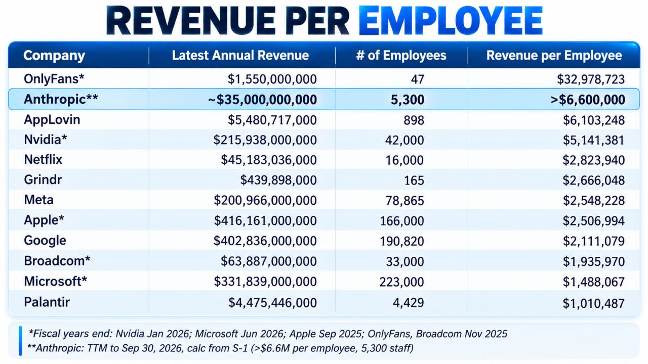

Source: Trung Phan

Chart #6: Are French stocks too cheap to ignore?

French equities are deeply out of favour, and the valuation gap has reached historic levels. After more than three years of underperformance, the CAC 40 trades at its lowest valuation relative to the eurozone on record, according to JPMorgan.

Investors have been pulling back from French assets, and sentiment remains very depressed.

For contrarian investors, the attraction is obvious. The harder question is whether the current discount represents a real opportunity or simply prices in the risks ahead.

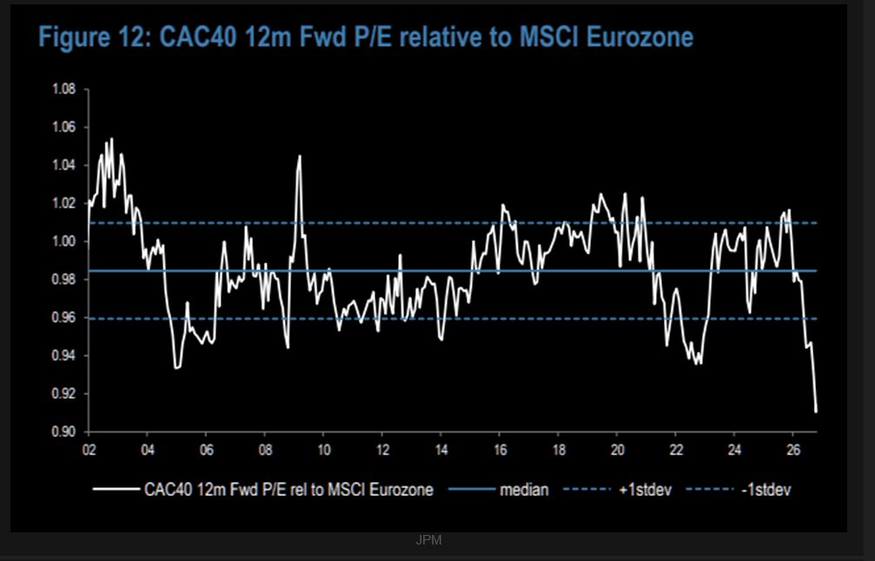

Source: JPM, TME

Chart #7: Europe’s falling share of world tech R&D

Europe aims to regulate the future. The question is who will build it.

Europe’s share of global technology R&D:
→ 2005: 23%
→ Today: 8%

Today, by contrast:
US: 62%
China: 15%
South Korea now invests more than Germany, France, the UK and Italy combined.

Europe does not lack talent, universities or capital.

What it increasingly lacks is an environment that rewards turning ideas into global companies.

Each additional layer of compliance absorbs resources, every obstacle to scaling pushes opportunities abroad, and every cut to the rewards for risk-taking erodes the incentive to innovate.

Regulation serves a purpose, as does redistribution, but neither can replace wealth creation.

Europe needs simpler rules, stronger investment incentives and greater ambition to build.

A continent cannot fund tomorrow’s prosperity by regulating yesterday’s success.

The choice is clear: build the next generation of global champions, or become an open-air museum for those who do.

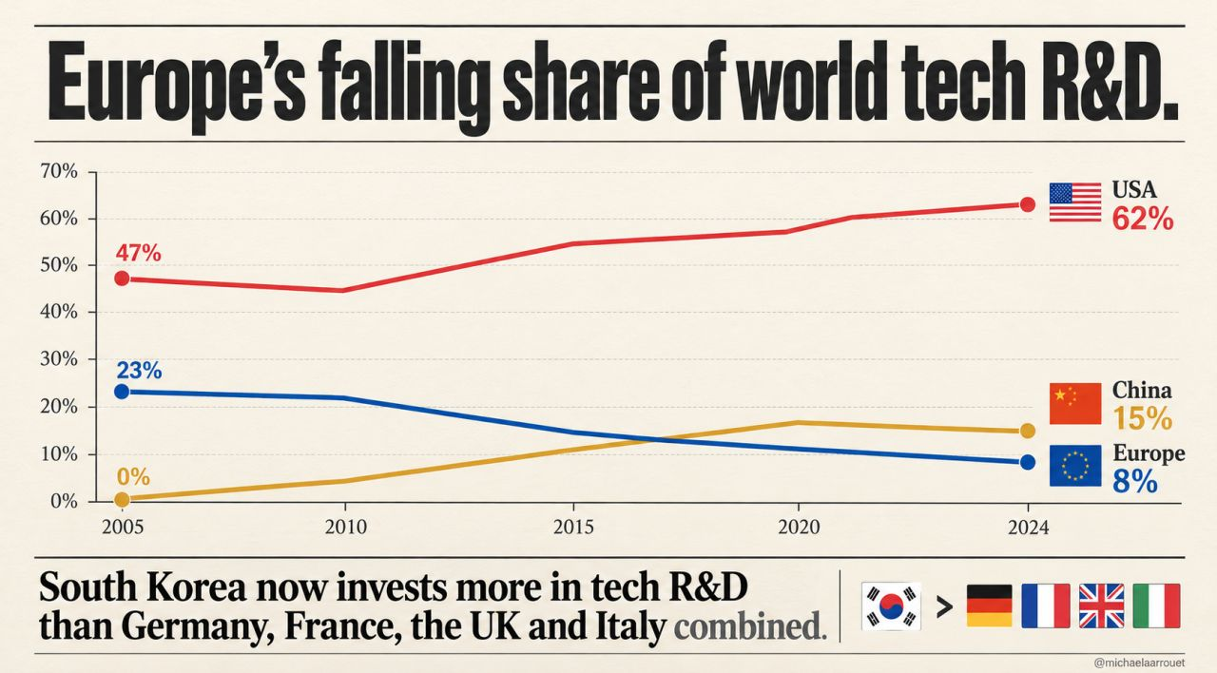

Source: Michel A.Arouet

